1. Control Charts

Control charts can be used to monitor process (e.g., manufacture of some item) quality over time to:

- Assess process stability
- Assess process capability
- Aid in process improvement

Chance causes or common causes are numerous small causes of variability that are inherent to a system or process and operate randomly.

Assignable or special causes of variability have relatively large effects on the process and are not inherent to it. The circumstances or factors that cause this kind of variability can be identified.

A stable process is in a state of statistical control and has only chance or common causes of variability operating on it. A process is said to be out of statistical control if one or more special causes are operating on it.

- Treating special causes as common causes invites further problems.
- Treating common causes as special causes is tampering or over-adjustment.

Control charts can be divided into two categories that are determined by the type of measurements used to monitor a process. These two broad categories are called attribute control charts (measures discrete variables) and variables control charts (measures continuous variables).

The attribute control charts:

1. Counts of nonconforming items charts
a. Pieces or number nonconforming charts (np Charts)
b. Fraction or proportion nonconforming charts (p Charts)

2. Area of Opportunity charts
a. Number of nonconformities charts (c charts)
b. Nonconformities per unit charts (u charts)

Control charts plot time on the x-axis, and outcomes on the y-axis. Bands demarcate degree of variation from mean or expected process performance:

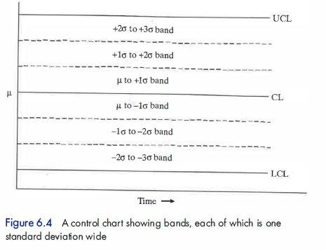
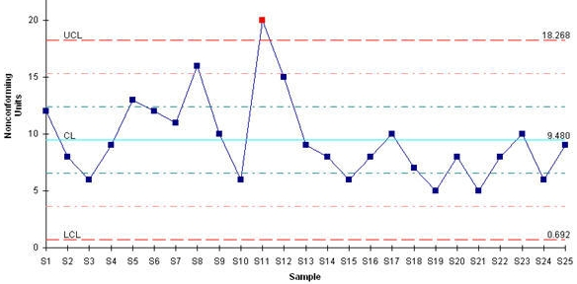

Center Line (CL) of a Control Chart. A line that represents the mean of the process in control.

Upper and Lower Control Limit (UCL & LCL) of a Control Chart. Lines that represent the limits to the variation of a process. An observation above the UCL or below the LCL suggests an uncontrolled or special-cause variation.

Chart-Based Diagnostics

Sometimes the general shape of a control chart suggests a particular type of process problem or trend.

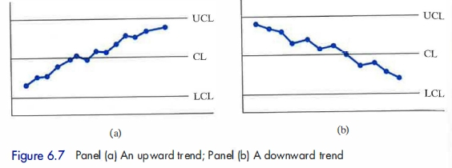
Trend Patterns

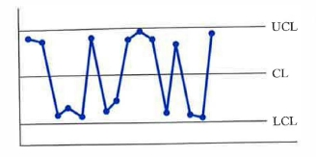
Mixture Pattern

A mixture pattern is characterized by alternately high and low values, with too few points plotted near the center line. It is often the result of mixing two underlying populations, such as two streams of raw materials, or the output of two machines or employees.

A process is considered out of control if any of the following occur:

- A point falls above the upper control limit or below the lower control limit.
- Two out of three consecutive points fall above the +2σ limits or two out of three consecutive points fall below the -2σ limits.
- Four out of five consecutive points fall above the +1σ limit or four out of five consecutive points fall below the -1σ limit.
- Eight or more consecutive points lie above the center line or eight or more consecutive points lie below the center line.
- Eight or more consecutive points move upward in value or eight or more consecutive points move downward in value.
2. Constructing an np Chart

Data

We need to evaluate at least 20 to 25 samples and count the number of nonconforming items in each.
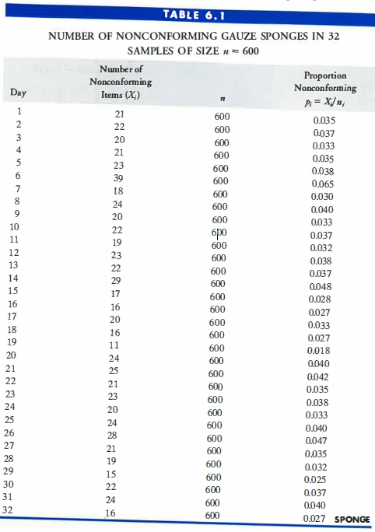
Formulae

$$\overline{p}=\frac{\text{Total number of nonconforming items in all samples}}{\text{Total number of items in all samples}}$$

$$\text{Center line }=n\overline{p}$$

where

n = the common sample size

$$s=\sqrt{n \overline{p} (1−\overline{p})}$$

$$\text{LCL}=n \overline{p}−3s$$
$$\text{UCL}=n \overline{p}+3s$$

Optional 1σ and 2σ Boundaries

$±$1σ boundaries$=n \overline{p}±s$
$±$2σ boundaries$=n \overline{p}±2s$

3. Making an np Chart in JMP

1. Download sponge data (sponge.xls)
2. Start JMP
3. File > Open > (navigate to sponge.xls)
4. Highlight all data columns
5. Analyze > Quality and Process > Control Chart > NP
6. For Process select Nonconformances
7. For Sample Size select Sample (or make Constant Size = 600)
8. OK
9. Press red arrow for NP of Nonconformances
10. Select Show Zones, Shade Zones, etc

As the data in Table 6.1 above may suggest, it's fairly simple to make an np chart with Excel. (Check for available templates online.)

Reading: pp. 230-253 (as required)

